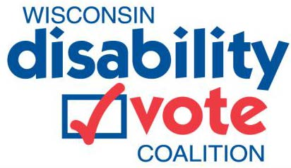

REV UP for National Disability Voter Registration Week
The Wisconsin Disability Vote Coalition invites you to join us as we participate in National Disability Voter Registration Week (NDVRW) from September 13th to 20th, 2021. NDVRW is a national and nonpartisan campaign to register, educate, and prepare voters with disabilities to vote in upcoming elections. REV UP stands for Register! Educate! Vote! Use your Power!

Join us to raise the disability voice and encourage civic participation! Here’s how to get involved:

Attend Our September 14th Voter Registration Webinar
Join the Wisconsin Disability Vote Coalition as we participate in National Disability Voter Registration Week with a webinar on everything you need to know about registering to vote, why voting matters, and making a plan to vote. The webinar is scheduled for Tuesday September 14 from 9 – 10 am.
- Register for the webinar at https://tinyurl.com/3ncks4s3
- View the event flyer at https://disabilityvote.org/wp-content/uploads/2021/08/NDVRW-Voter-Registration-Webinar-Flyer-acc.pdf.

Attend Our September 17th Voter Registration Webinar for Service Providers
Join the Wisconsin Disability Vote Coalition and our partners for our National Disability Voter Registration Week webinar for service providers. We will share guidance and resources to help you support those you serve with voter registration and obtaining photo ID. Service providers can make a big difference by assisting with voter registration.
- Register for the webinar at https://tinyurl.com/5pvbunkh
- View the event flyer at https://disabilityvote.org/wp-content/uploads/2021/08/NDVRW-Service-Provider-Webinar-Flyer-acc.pdf

Join Us to Promote Voter Registration:
- Social Media: Like and share Wisconsin Disability Vote Coalition’s posts on Facebook.
- Voter Registration Status: Check your voter registration status on MyVoteWisconsin. If you aren’t registered to vote, register now! If you are registered, make sure your information is current.
- Voter Registration Events: Host a voter registration event with a community partner.
  - Contact the League of Women Voters in your area and ask them to partner for your event: https://my.lwv.org/wisconsin/join-your-local-league
  - Ask the Disability Vote Coalition to help you organize an event and share materials. Email us at info@disabilityvote.org or call the DRW Voter Hotline at 844-347-8683
  - Ask your Municipal Clerk if they can help you with a voter registration event. Find your clerk at: https://myvote.wi.gov/en-us/My-Voter-Info
- Voter Registration Resources Toolkit: Include voter registration materials on your website and social media. Check out our Voter Registration Resources Toolkit at https://disabilityvote.org/2021/voter-registration-resources-toolkit/
- Supporting People with Disabilities: If you support people with disabilities, develop a plan to help with voter registration.
  - On your next visit or call, ask participants if they are registered to vote and if they would like to receive assistance.
  - Send out a mailing with information about voter registration and how to get help.
  - Promote voter registration in your newsletters.
  - Attend our webinar for service providers scheduled for noon on Friday September 17th.
Justin Dart, father of the Americans with Disabilities Act (ADA), said it best: “Vote as if your life depended on it, because it does.”

